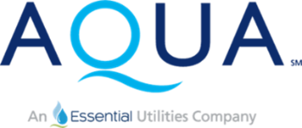

Water Service Advisory Council Meeting Agenda
Date: Tuesday, September 17, 2024
Time: 7:00 – 8:00 p.m.
Location: Zoom Virtual Meeting

7:00 p.m.
Welcome and Opening Remarks
David Carter, President Aqua Illinois

7:05 p.m.
Updates & Progress Report
Aqua Illinois Leadership Staff

7:20 p.m.
July Hydrant Branch Break Case Study
Aqua Illinois Leadership Staff

7:35
Water Treatment Plant Project Plan
Tracey Fullen, Engineering Manager, Aqua Illinois

7:45
Rate Case Update
Aqua Illinois Leadership Staff

7:55 p.m.
Next Steps & Open Forum for Questions
All

8:00 p.m.
Adjournment

